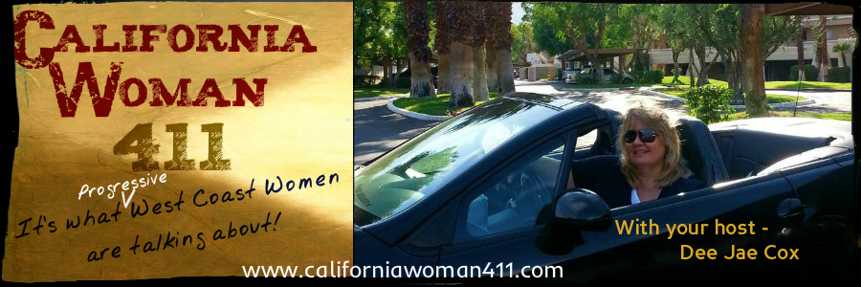

Talking to Women who Lead and Inspire.....
.....and discussing topics that affect women most

FOR IMMEDIATE RELEASE
September 4, 2013

Contact: Michele Weiss, Executive Producer
818-720-2056
mweiss@lawomenstheatreproject.org

“California Woman 411”
An Edgy…Progressive…Thought Provoking Talk Radio Show for Women about Women, where we’ll be ‘Talking to women who lead and Inspire and discussing topics that affect women most.’

Date: Saturday mornings from 10 -11am, beginning September 21, 2013.
Location: RR Broadcasting 2100 Tahquitz Canyon Way, Palm Springs, CA

‘California Woman 411’, is a Progressive Talk radio show with host Dee Jae Cox, (a writer, producer, director, feminist, political junkie and U.S. Army Vet.) and will air on September 21, 2013, on KPTR 1450 AM in Palm Springs, CA.

‘California Woman 411’ will feature Women In The Arts, interviews with women in the fields of Theatre, Film, Television, Music & Literature. Women In Business, Women Philanthropist or who own or manage a business. Women In Politics discussing current political issues that are of interest and significance to women. Women In The Community and Information on Events and Services for Women.

‘California Woman 411’ inaugural guests will feature City Council member Ginny Foat and Coachella Valley Studios Cofounder, Leanna Bonamichi.. Each weekly show will feature interviews, news and opinions that affect women and can be heard from anywhere by podcast found on: www.californiawoman411.com, as well as by iphone/ipad applications.

“California Woman 411” is Produced by Michele Weiss, under the auspice of The LA Women’s Theatre Project (www.lawomenstheatreproject.org), a nonprofit organization whose mission is to create more opportunities for women’s voices in the performing arts.

For more information contact: www.californiawoman411.com.

For guest booking information contact: Nora Gleason, booking Producer, ngleason@californiawoman411.com.

For all other show information including sponsorship, contact: Michele Weiss, Executive Producer. Cell: 818-720-2056 or send inquiry to mweiss@lawomenstheatreproject.org.

